**TUGAS REKAYASA PERANGKAT LUNAK**

**(VAMPIRESPORT WEBSITE)**

**STUDI KASUS : BLACKBOX AND WHITEBOX**



**TUGAS REKAYAS PERANGKAT LUNAK**

Disusun oleh :

**Ilyas Abdurahman Yusuf(16090069)**

**Kelas : 6C**

**POLITEKNIK HARAPAN BERSAMA**

**T E G A L**

**2019**

1. **WHITEBOX:**
2. **Flowchart Diagram**

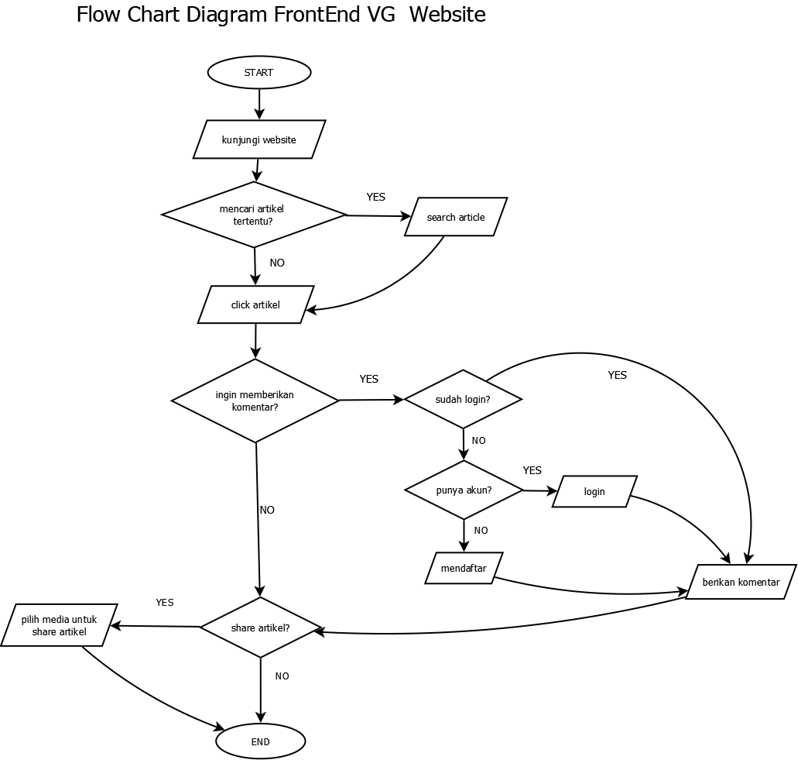

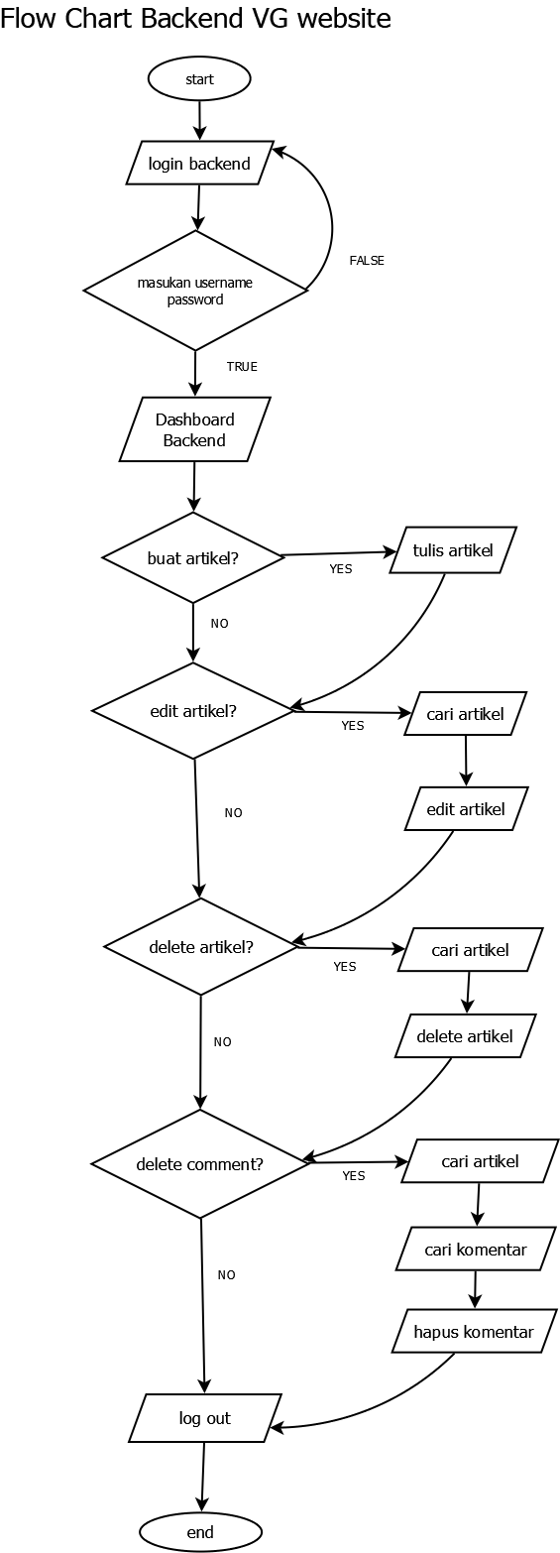

1. **CFG :**

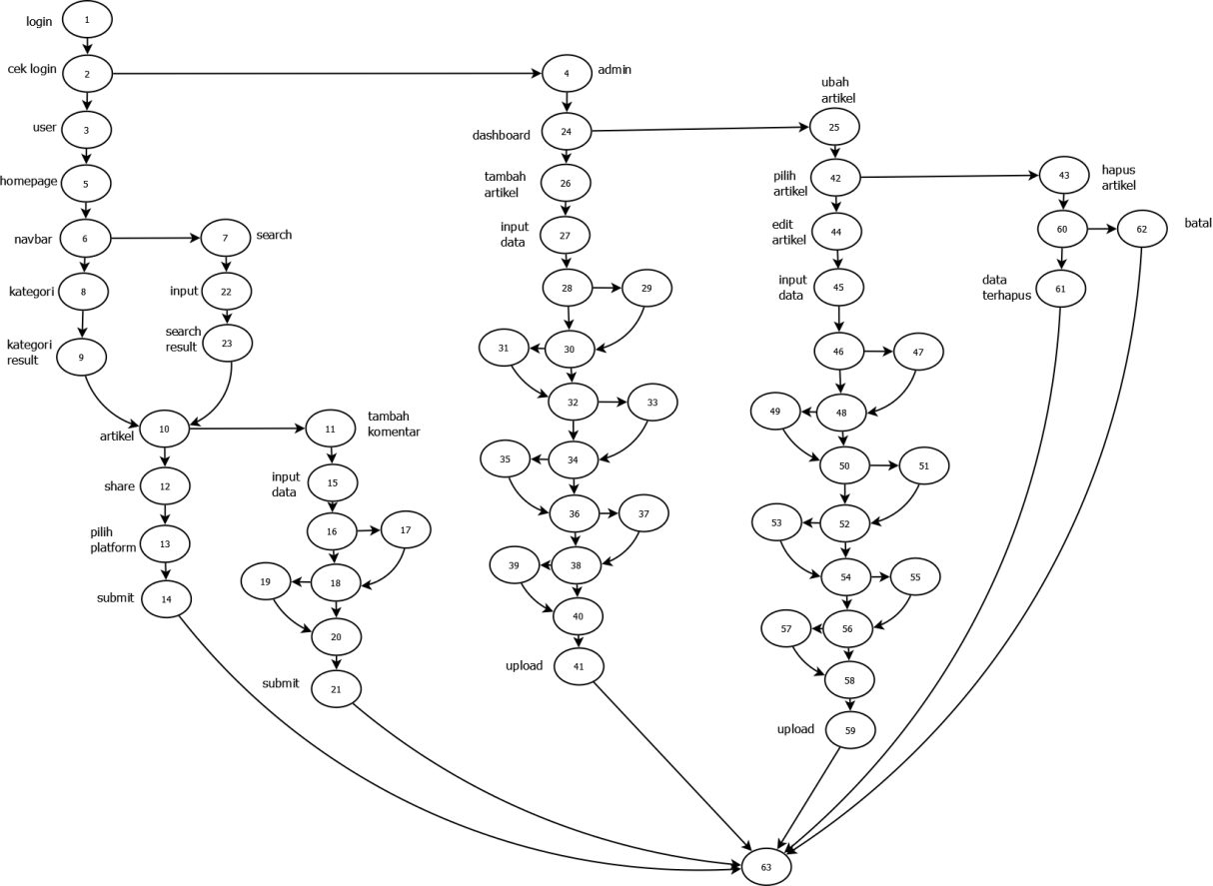

1. **Cyclomatic Complexity :**

jika

E = 81, N = 63

hitung V(G) ?

V(G) = E - N + 2

V(G) = 81 - 63 + 2

V(G) = 20

1. Black Box Testing
2. **Equivalent:**

Artikel : 500 character

|  |  |  |  |
| --- | --- | --- | --- |
| invalid | valid | | invalid |
| <>@#^%*/|[] | ()&.,’” | 0-9 A-Z | >500 character |
| null | 500 character | 500  character | 501 character |

Komentar : 200 character

|  |  |  |  |
| --- | --- | --- | --- |
| invalid | valid | | invalid |
| <>#^%*/|[] | ()&.,’”@ | 0-9 A-Z | >200 character |
| null | 200 character | 200 character | 201 character |

1. **Tabel Kebenaran**
2. Validasi Login

|  |  |  |  |  |
| --- | --- | --- | --- | --- |
| Username | F | F | T | T |
| Password | F | T | F | T |
| Hasil | F | F | F | T |

1. Artikel & Komentar :

|  |  |  |  |  |
| --- | --- | --- | --- | --- |
| Artikel | F | F | T | T |
| Komentar | F | T | F | T |
| Hasil | F | F | T | T |

1. Artikel & Share :

|  |  |  |  |  |
| --- | --- | --- | --- | --- |
| Artikel | F | F | T | T |
| Share | F | T | F | T |
| Hasil | F | F | T | T |

1. Search Input :

|  |  |  |  |  |
| --- | --- | --- | --- | --- |
| Judul | F | F | T | T |
| Kategori | F | T | F | T |
| Hasil | F | T | T | T |

1. Tambah Komentar

|  |  |  |  |
| --- | --- | --- | --- |
| **Nama** | **Email** | **Pesan** | **Action** |
| F | F | F | F |
| F | F | T | F |
| F | T | F | F |
| T | F | F | F |
| T | T | F | F |
| T | F | T | F |
| F | T | T | T |
| T | T | T | T |